Views

Lab2_1

Câu 1:

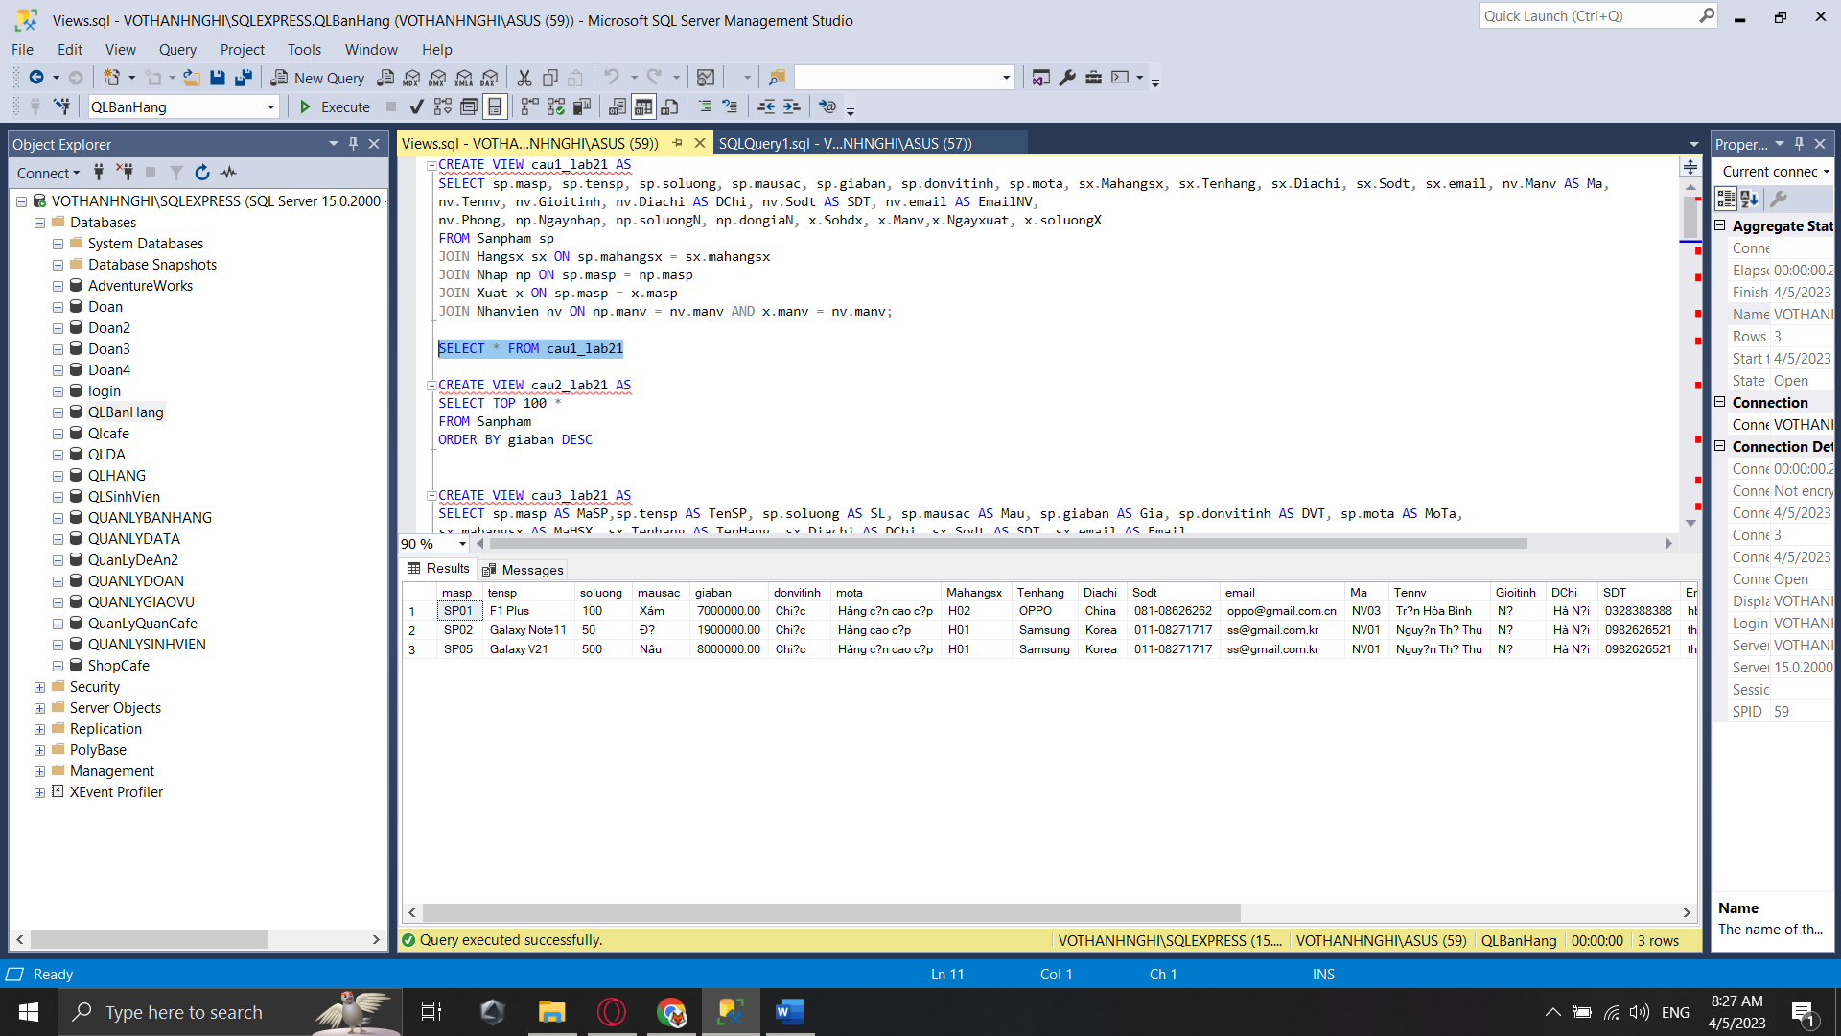

Câu 2:

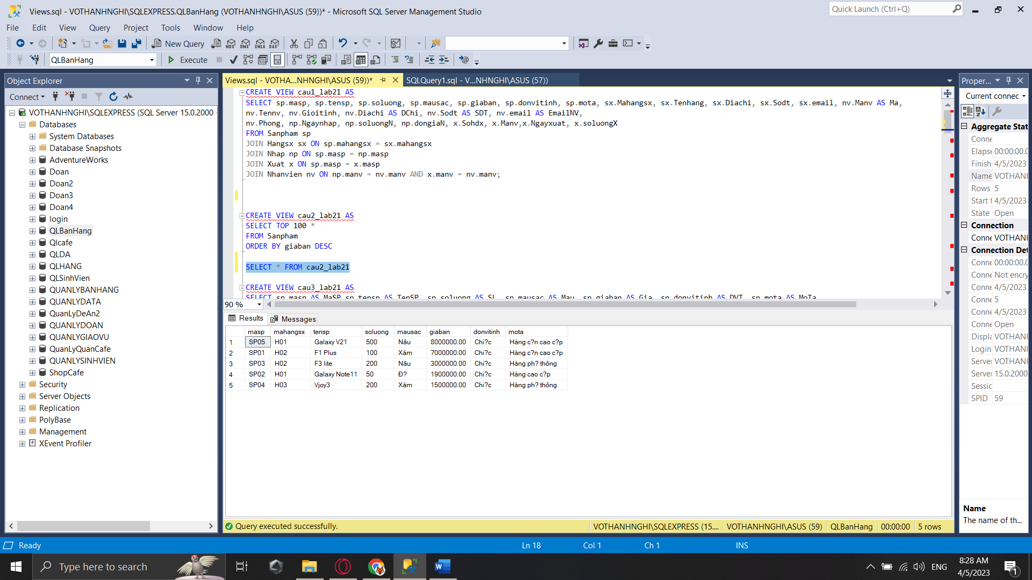

Câu 4:

Câu 6:

Câu 8

Câu 10:

Câu 12:

Câu 14:

Câu 16:

Lab2_2

Câu 18:

Câu 19: 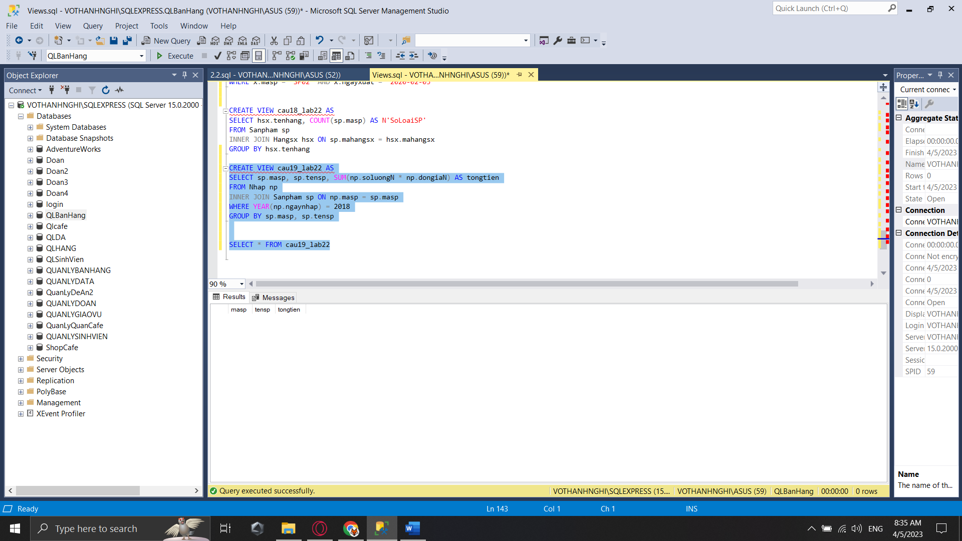

Câu 20:

Câu 22:

Câu 24:

Câu 25: 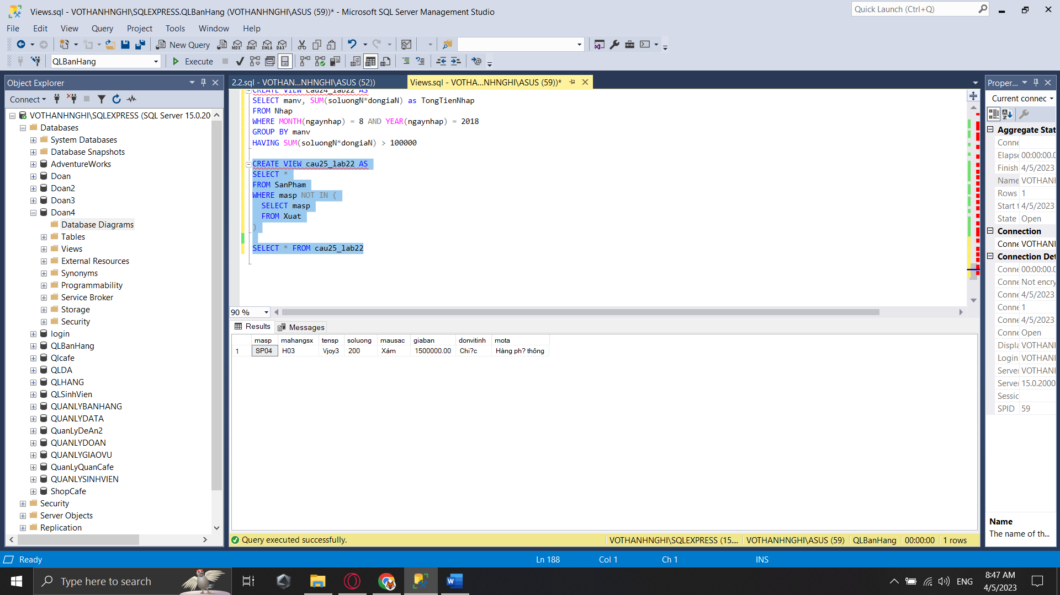

Câu 26:

Câu 27: 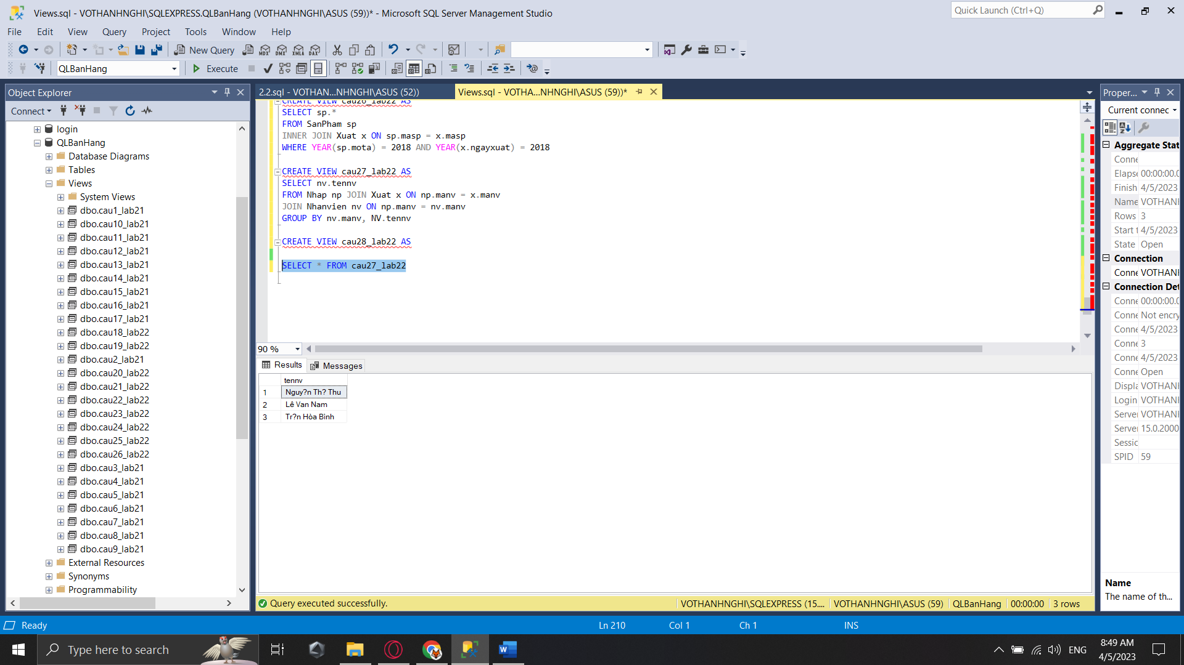

Câu 28:

